Additional File 2 for
Spatial patterns of microbial nitrogen genes along precipitation gradient in different temperate grasslands of Inner Mongolia, China
Running title: N gene spatial pattern in temperate grassland
Shutong Zhouª, Kai Xue^{bac*}, Biao Zhangª, Li Tang^{ad}, Zhe Pangª, Fang Wang^{ad}, Rongxiao Che^{e}, Qinwei Ranª, Anquan Xiaª, Kui Wangª, Linfeng Li^{ad}, Junfu Dongª, Jianqing Duª, Ronghai Huª, Yanbin Hao^{ac}, Xiaoyong Cui^{ac}, Yanfen Wang^{ac*}
ª University of Chinese Academy of Sciences, Beijing 100049, China
^{b} Key Laboratory of Environmental Biotechnology, Chinese Academy of Sciences (CAS), Beijing 100085, China.
^{c} CAS Center for Excellence in Tibetan Plateau Earth Sciences, Beijing 100101, China
^{d} Environmental Futures Research Institute, Griffith University, Nathan QLD 4111, Australia
^{e} Institute of International Rivers and Eco-security, Yunnan University, Kunming 650091, China
* Author for correspondence
The file includes:
Supplementary Figures: 8
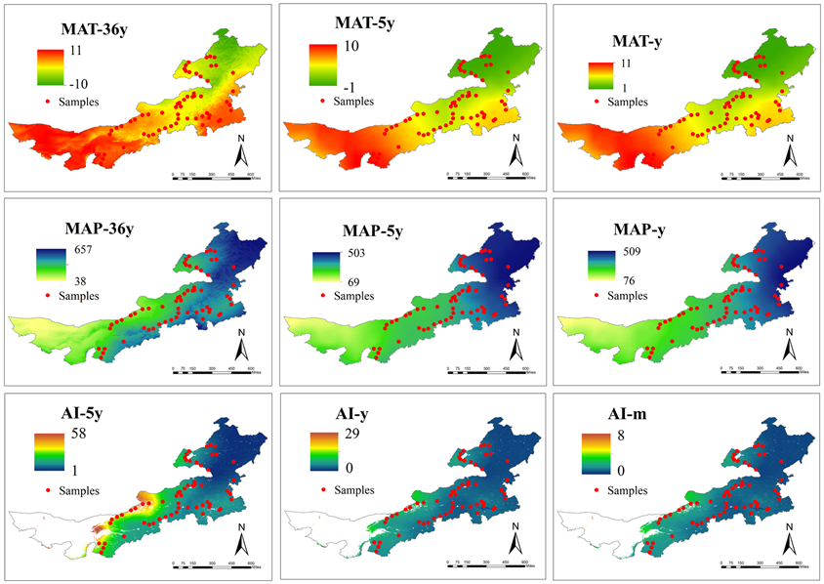
Figure S1 Spatial pattern of MAT-36 y, MAT-5 y, MAT-y, MAP-36 y, MAP-5 y, MAP-y, AI-5 y, AI-y, AI-m.
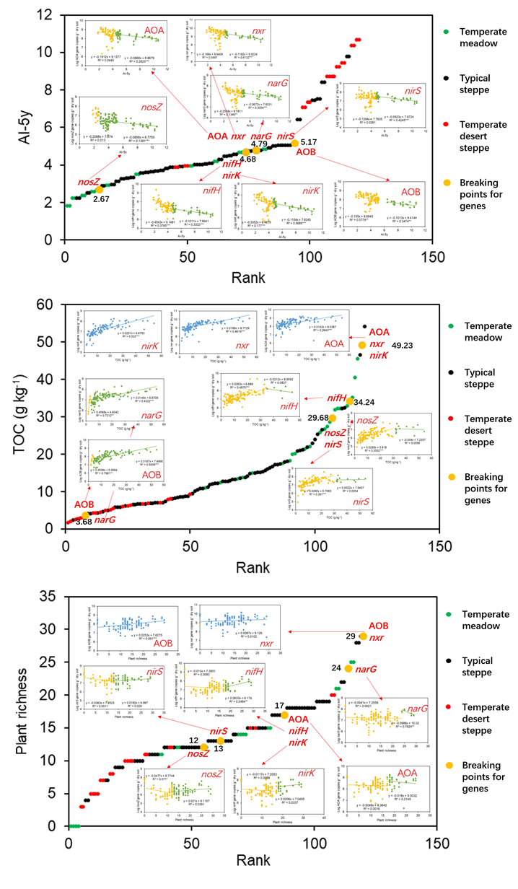
Figure S2 Response patterns of log-transformed N gene copy numbers along AI-5y, TOC and plant richness. Breaking points were automatically identified by piecewise regression. Significance levels are represented as follows: *P < 0.05, **P < 0.01 and ***P < 0.001.
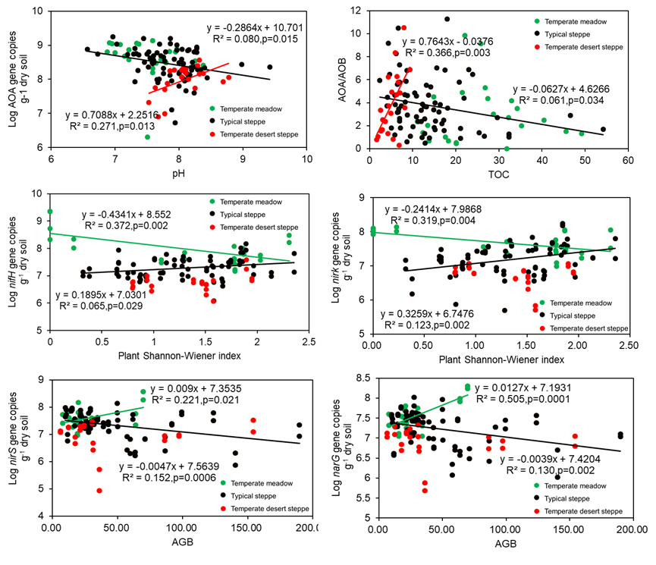
Figure S3 Log transformed N gene copy numbers along measured environmental variables in temperate meadow (green), typical steppe (black), and temperate desert steppe (red). Only signficant correlation by pearson test were presented.
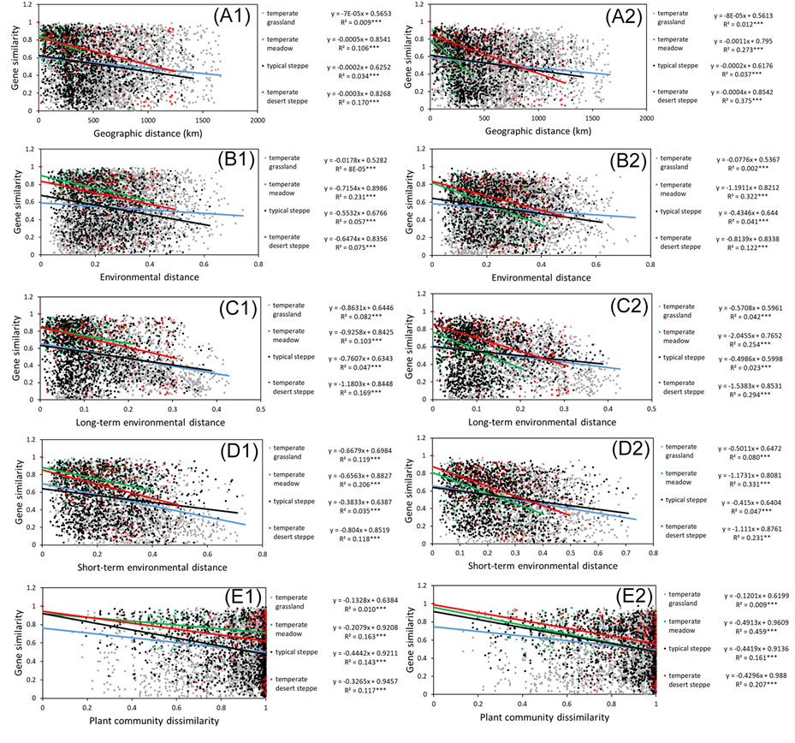
Figure S4 Relationships for similarities of nitrification (AOA, AOB and nxr) and denitrification (nirS, nirK, nosZ and narG) gene communities over geographic distance (A1 and A2), environmental distances based on all measured environmental variables (B1 and B2), long-term environmental variables (C1 and C2), short-term environmental variables (D1 and D2), or plant community dissimilarity (E1 and E2). Similarities or dissimilarities were calculated based on Bray-Curtis.
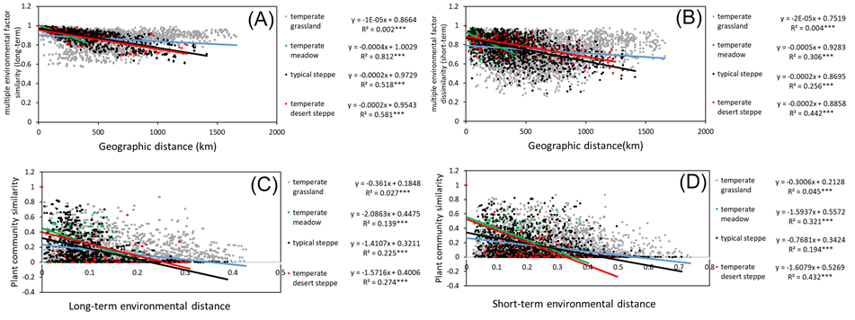
Figure S5 Decay relationship for or long-term environmental variables (A), short-term environmental variables (B) over geographic distance, as well as plant community similarities over long-term environmental distance based on long-term environmental variables (C) or short-term environmental distance based on short-term environmental variables (D) Similarities or dissimilarities were calculated based on Bray-Curtis.

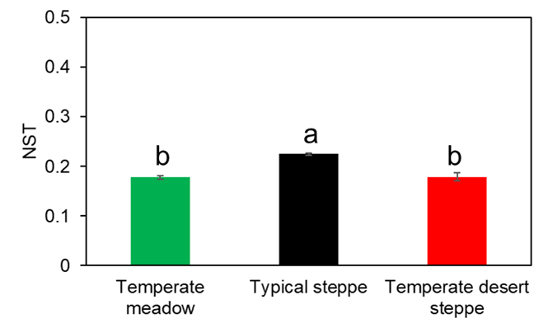
Figure S6 Normalized stochasticity ratio (NST) in temperate meadow, typical steppe, temperate desert steppe.

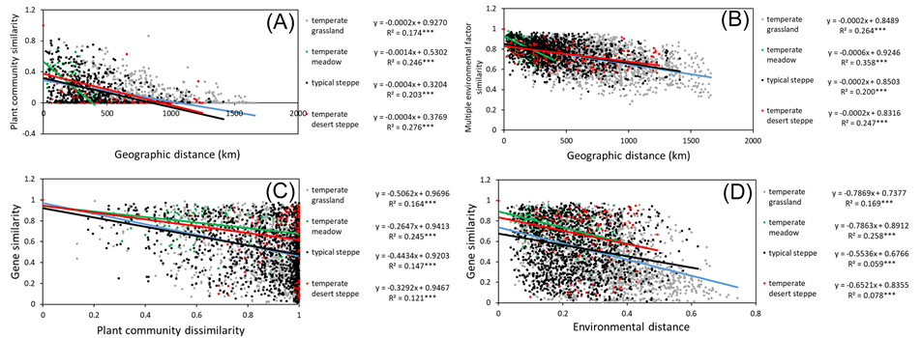
Figure S7 Decay relationship for plant community dissimilarities (A), environmental distances based on all measured environmental variables (B) over geographic distance, as well as N gene similarity over plant community dissimilarities (C), environmental distances based on all measured environmental variables (D). Similarities or dissimilarities were calculated based on Bray-Curtis.
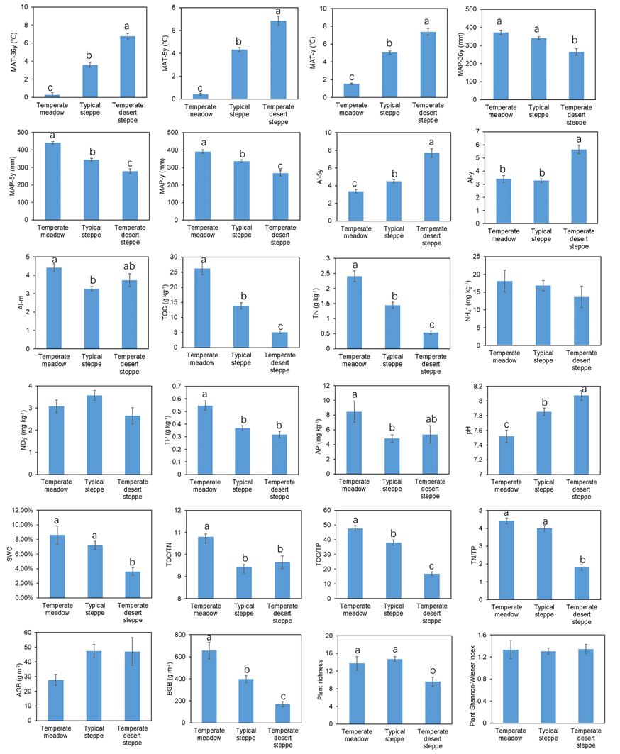
Figure S8 Changes in measured environmental variables in temperate meadow, typical steppe, temperate desert steppe.

